How to add new Flight Data
If you have already added data on this computer previously, only execute Step 3 and 7-12
Prerequisites:
Python 3 (https://www.python.org/downloads/) (Python 3.12)
VS Code (https://code.visualstudio.com/download) + “Python” extension (Ctrl+Shift+X) in VS
Git (https://gitforwindows.org/)
TortoiseGit (https://tortoisegit.org/download/)
Admin Rights for Tool Repository (https://github.com/HSP-admin/flight-data-evaluation-tool)

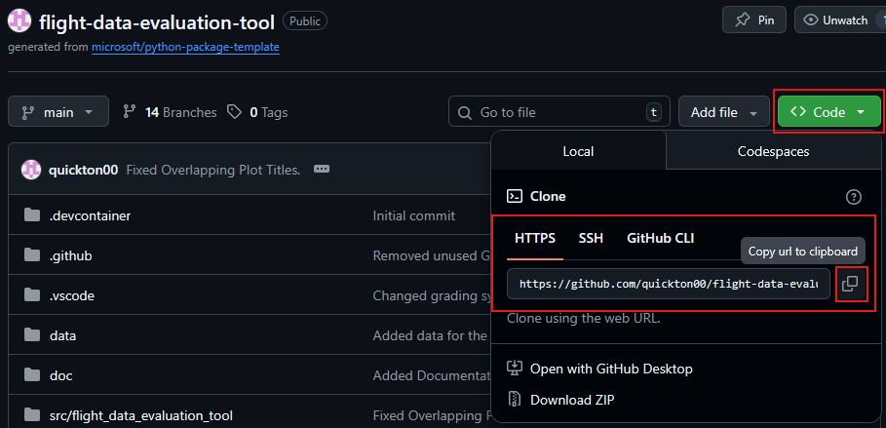
Copy Repository URL to clipboard (Github URL see above)

Clone Repository
Shift+right click in the folder (Windows File Explorer) where the repository should be created
Select Git clone…
URL from clipboard should be used automatically
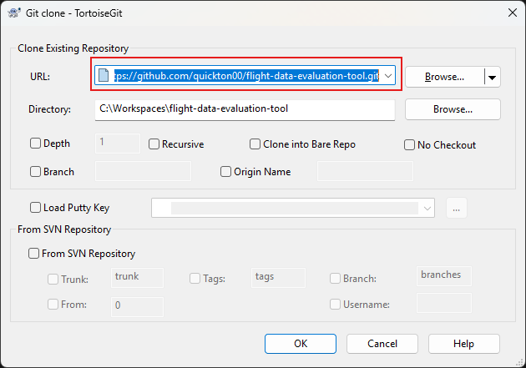
Press OK

Pull the latest Version of the software*
Shift+right click in the top-level folder (Windows File Explorer) of the repository
Select TortoiseGit -> Pull…
Press OK

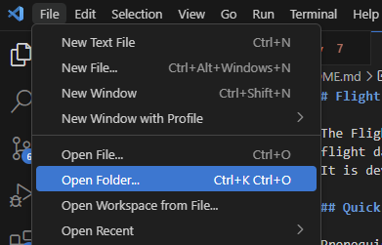
Open the repository in VS-Code
Select the folder of the Repository (flight-data-evaluation-tool)
Setup Venv via VS-Code: (open terminal via Ctrl+Shift+Ö)
py -3.12 -m venv .venv (Adjust to your python version, here Python 3.12)
.\.venv\Scripts\Activate.ps1
If activation is blocked:
Set-ExecutionPolicy -Scope CurrentUser RemoteSigned
.\.venv\Scripts\Activate.ps1

Install dependencies via PowerShell in VS Code
python -m pip install -U pip
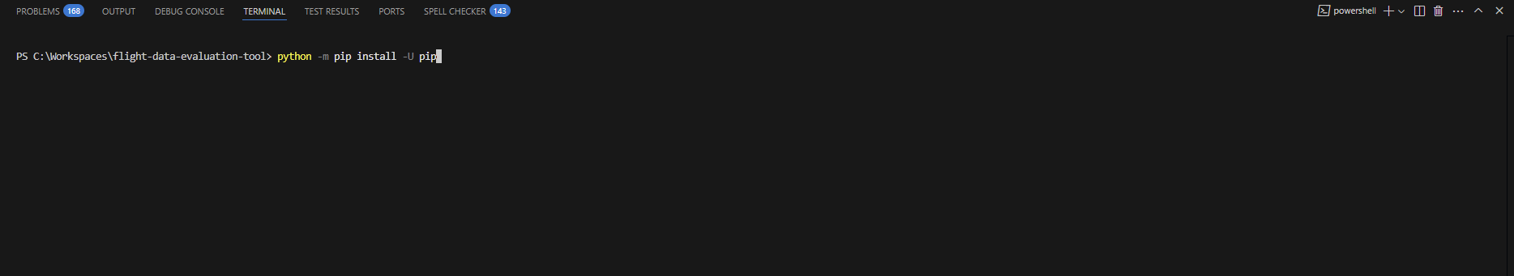
pip install -r requirements.txt

Select the interpreter in VS Code
Ctrl+Shift+P → “Python: Select Interpreter” → choose .venv\Scripts\python.exe

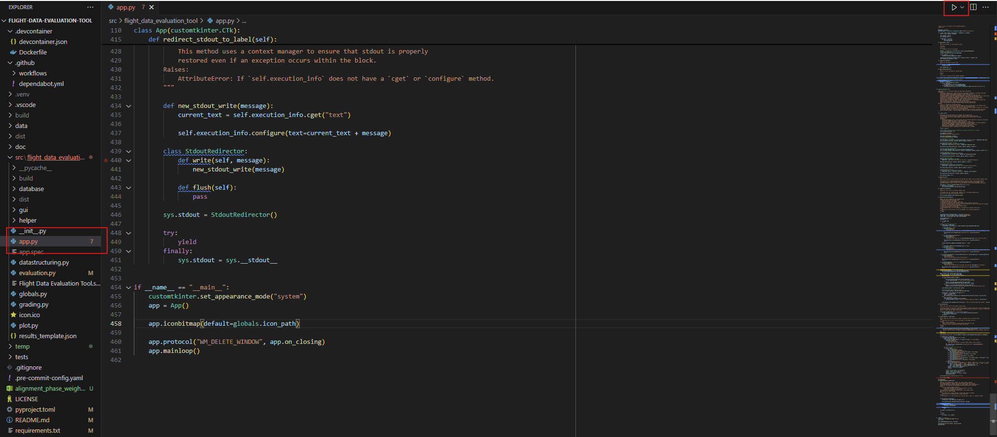
Run the app*
Select the app.py from the File Explorer
Press Run in the upper right corner

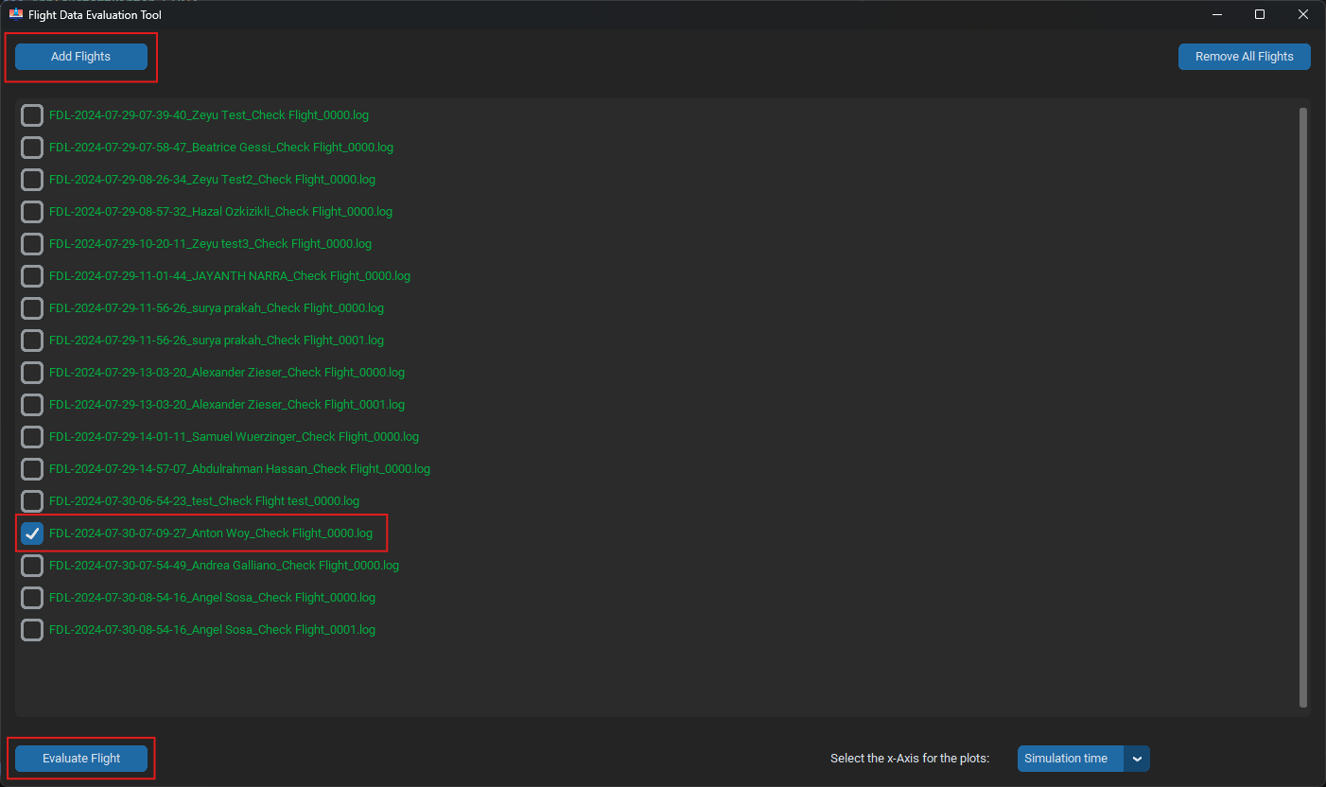
Select the Flight you want to add to the database*

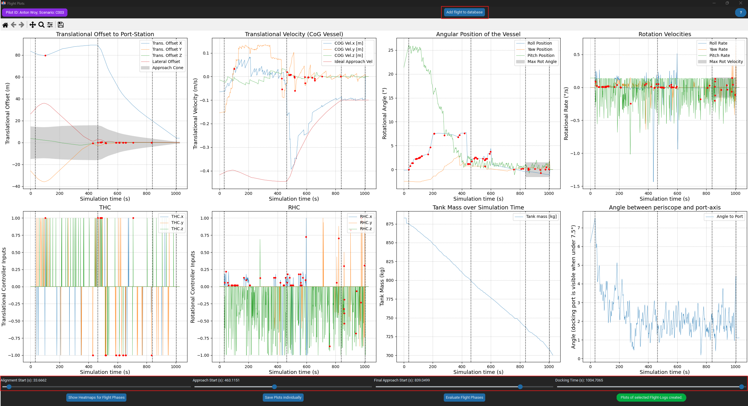
Correct Phases if needed and add File to database*

Correct Phases via phase sliders
Click Add Flight to database button in top right corner

10. Repeat Step 8 and 9 for all flights you want to add*

11. Commit all changes to the GitHub Repository*
Shift+right click in the top-level folder (Windows File Explorer) of the repository
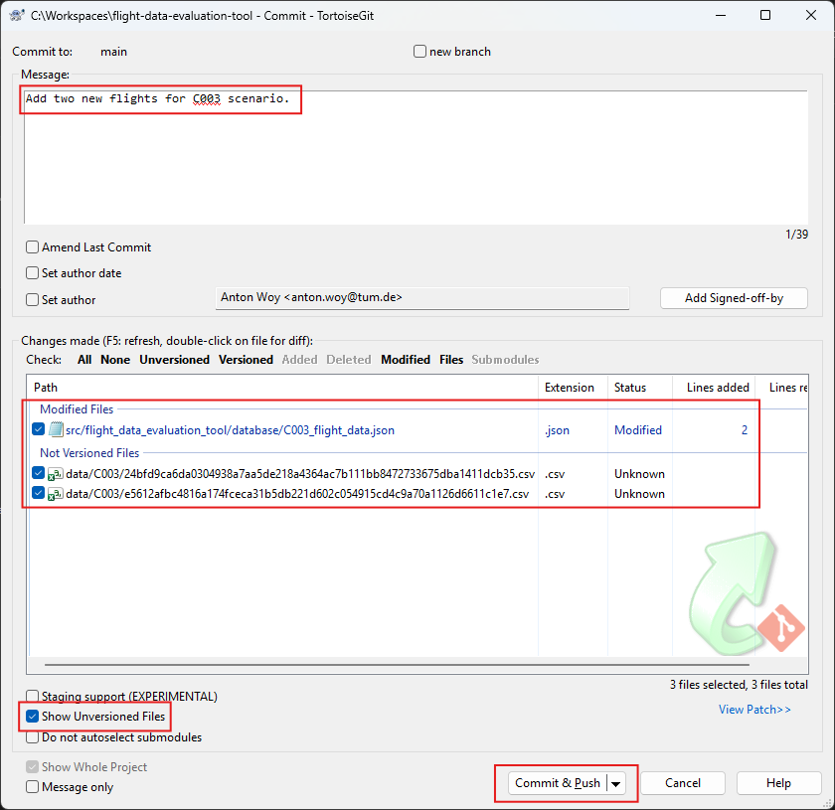
Select Git Commit -> “Main”…
Write meaningful Commit Message
Make sure all files are selected
Press Commit and Push

12. Build new Standalone exe-File with your updated database with PowerShell*
1. Install pyinstaller:
pip install pyinstaller
2. Navigate to the folder where app.py is located, e.g.:
cd .\src\flight_data_evaluation_tool\
3. Build .exe: (might take a while)
pyinstaller --clean '.\Flight Data Evaluation Tool.spec'
new Exe is located under:
<your directory>\flight-data-evaluation-tool\src\flight_data_evaluation_tool\dist\Flight Data Evaluation Tool.exe

